**WorkWize – Project Management Tool**

**Major Project**

**CS 816: Software Production Engineering**

Guided By

|  |
| --- |
| **B. Thangaraju** |
| **Professor** |
| **International Institute of Information Technology, Bangalore** |
|  |
| Under the Assistance of |
| **Samaksh Dhingra** |
| **Teaching Assistant** |
|  |



**International Institute of Information Technology, Bangalore**

Created by:

|  |  |  |
| --- | --- | --- |
| **Vraj Jatin Naik** |  | **Arjun Gangani** |
| **MT2023050** |  | **MT2023153** |
| **Vraj.Naik@iiitb.ac.in** |  | **Arjun.Gangani@iiitb.ac.in** |

# ABSTRACT

In industrial settings, traditional project management methods often lack efficiency and responsiveness due to manual processes and disjointed workflows. Existing systems may not sufficiently address the specific needs of industrial projects, leading to challenges in coordination, task assignment, and progress tracking. There is a growing demand for platforms that can accommodate real-time user feedback and updates.

The project "WorkWize" aims to address these challenges by developing a comprehensive project management platform tailored for industrial environments. The primary objective is to enhance project workflows and facilitate effective management by all stakeholders. WorkWize incorporates roles for employees, managers, and administrators, each with specific functionalities to streamline project execution and oversight.

Employees can view assigned tasks, update progress, and visualize their task history, while managers can create, update, and delete projects, track progress, and manage time and effort distribution. Administrators oversee user management and system administration, ensuring smooth operation and handling technical issues.

Utilizing a robust tool stack including AngularJS for the front end, Spring Boot for the back end, and MySQL for the database, WorkWize leverages DevOps tools such as GitHub, Jenkins, Docker, Docker Compose, Ansible, and the ELK stack to automate the CI/CD pipeline, ensure efficient application management, and provide comprehensive log analysis. This integration of tools and methodologies results in a streamlined, efficient, and responsive project management solution.

# TABLE OF CONTENTS

ABSTRACT I

TABLE OF CONTENTS II

LIST OF FIGURES III

1. INTRODUCTION 1

2. APPLICATION FEATURE 2

2.1 ROLES 2

2.2 ROLE-WISE FUNCTIONALITIES 2

3. ARCHITECTURE 5

3.1 SYSTEM ARCHITECTURE 5

3.2 SYSTEM CONFIGURTION 6

**3.2.1** **PROJECT TECHNOLOGY STACK** 6

**3.2.2** **INFRASTRCTURE DETAILS** 7

**3.2.3** **DEV-OPS TOOLS** 8

4. DESIGN 9

4.1 USE CASE DIAGRAM 9

4.2 CLASS DIAGRAM 10

5. SOFTWARE DEVELOPMENT LIFE CYCLE 11

5.1 FRONTEND 12

**5.1.1** **INSTALLATION** 12

**5.1.2** **SOURCE CODE MANAGEMENT** 13

**5.1.3** **CONTINUOUS INTEGRATION** 15

**5.1.4** **DOCKER BUILD AND PUSH** 16

**5.1.5** **DOCKER COMPOSE** 17

**5.1.6** **FRONT END CODE** 17

5.2 BACKEND 20

**5.2.1** **INSTALLATION** 20

**5.2.2** **SOURCE CODE MANAGEMENT** 20

**5.2.3** **DOCKER BUILD AND PUSH** 21

**5.2.4** **CONTINUOUS DEPLOYMENT USING ANSIBLE** 23

**5.2.5** **BACKEND CODE** 25

5.3 CONTINUOS MONITORING 29

**5.3.1** **ELASTIC SEARCH** 30

# LIST OF FIGURES

Figure 4‑1Use Case Diagram 9

Figure 4‑2 Class Diagram 10

Figure 5‑1 DevOps Tool Chain 11

Figure 5‑2 DevOps Benefits 11

Figure 5‑3 Update System 12

Figure 5‑4 Prerequisite Installation 12

Figure 5‑5 Angular Installation 12

Figure 5‑6 Angular Installation Verification 12

Figure 5‑7 Run Angular 13

Figure 5‑8 Git Initialization 13

Figure 5‑9 Add Remote Origin 13

Figure 5‑10 Staging File 13

Figure 5‑11 Git Commit 13

Figure 5‑12 Git Push 14

Figure 5‑13 Front End Git Clone - I 14

Figure 5‑14 Front End Git Clone - II 14

Figure 5‑15 Git Architecture 14

Figure 5‑16 Continuous Integration 15

Figure 5‑17 Second Step 15

Figure 5‑18 Production Environment 16

Figure 5‑19 Third Step 16

Figure 5‑20 Fourth Step 17

Figure 5‑21 Angular Creating Component 17

Figure 5‑22 Front End Directory Structure 18

Figure 5‑23 Angular Creating Service 18

Figure 5‑24 API Call to Back End 19

Figure 5‑25 API Call from Service to Component 19

Figure 5‑26 Maven Install 20

Figure 5‑27 Maven Installation verification 20

Figure 5‑28 Clean And Install Maven 20

Figure 5‑29 Git Clone 21

Figure 5‑30 Git initialization Backend 21

Figure 5‑31 Git Clone Backend - II 21

Figure 5‑32 Docker File Backend 21

Figure 5‑33 Docker Compose File Backend 22

Figure 5‑34 Ansible Playbook Backend 24

Figure 5‑35 Backend Directory Structure 25

Figure 5‑36 JWT Token Verification 27

# INTRODUCTION

Workflow management is the process of optimizing data paths in a given process. It involves creating and optimizing the sequence of tasks required to complete a particular project. A Workflow Management System (WMS) automates this process by creating a form to hold data and automating a sequential path of tasks for the data to follow until it is fully processed. By automating repetitive processes, a WMS such as WorkWize frees up time and resources for more important tasks. Additionally, it ensures that uncompleted tasks are automatically followed up on, reducing the risk of errors or delays.

WorkWize is an efficient WMS that provides a range of features for workflow management and automation. Its customizable forms allow for the creation of unique workflows that meet the specific needs of any project. The system provides real-time monitoring of progress, allowing for easy tracking of project status and identification of potential bottlenecks. The system also generates detailed performance metrics, providing insights into how to optimize the workflow further.

The scope of WorkWize is broad, as it is suitable for any industry, whether small-scale or large-scale, that requires workflow management and automation. By using WorkWize, organizations can increase productivity, improve efficiency, and reduce errors and delays.

# APPLICATION FEATURE



## ROLES

1. **Employee:**

Role Description: Employees execute assigned tasks within projects under the guidance of managers.

1. **Manager:**

Role Description: Managers oversee projects and task assignments, ensuring smooth workflow and project progress.

1. **Admin:**

Role Description: Administrators have the highest level of access and are responsible for managing users, including adding and removing employees and managers, as well as overseeing the overall system administration.

## ROLE-WISE FUNCTIONALITIES

1. **EMPLOYEE:**

* **Tasks Related:**

Description: Employees can view tasks assigned to them.

Actions:

1. **View Assigned Tasks:**

Description: Employees can see tasks assigned to them under projects.

1. **Update Task Progress:**

Description: Employees can update the progress status of tasks assigned to them.

1. **Visualize Personal Progress:**

Description: Employees can visualize their progress as per the tasks assigned to them.

* **View Profile:**

Description: Employees can view their personal details and task history.

Actions:

* View personal details
* View task history
* **Reset Password:**

Description: Employees can reset their passwords if forgotten.

Actions:

* Request password reset
* Set new password

1. **MANAGER:**

* **Create, Update, and Delete Projects:**

Description: Managers can create new projects, update existing projects, and delete projects they have created.

Actions:

* Create new projects
* Edit existing projects
* Delete projects from the system
* **Manage Employees:**

Description: Managers can add employees to projects and manage them by assigning tasks related to the project.

Actions:

* Add employees to projects
* Assign tasks to employees
* **Project Progress Monitoring:**

Description: Managers can track the progress of their projects.

Actions:

* View project progress
* **Time and Effort Distribution:**

Description: Managers can allocate and adjust time distribution and visualize effort distribution.

Actions:

* Give/edit distribution of time in the project effort table
* Visualize effort distribution
* **Reset Password:**

Description: Managers can reset their passwords if forgotten.

Actions:

* Request password reset
* Set new password

1. **ADMIN:**

* **Manage Users:**

Description: Admins can add, view, edit, and remove users (both employees and managers) from the system.

Actions:

* Add new users
* View user profiles
* Edit user profiles
* Delete user accounts
* **System Administration:**

Description: Admins oversee the overall system administration, ensuring its smooth operation and handling any technical issues.

Actions:

* Handle system configurations
* Perform maintenance tasks
* Address technical issues and escalations

# ARCHITECTURE

## SYSTEM ARCHITECTURE

* **FRONTEND**
* **Framework:** Angular
* **Description:** The frontend is a single-page application (SPA) built using Angular. It handles user interactions, renders dynamic content, and communicates with the backend via RESTful APIs.
* **BACKEND**
* **Framework:** Spring Boot
* **Description:** The backend consists of Spring Boot Web REST Controllers. It processes HTTP requests from the frontend, handles business logic, and interacts with the database to retrieve and store data.
* **DATABASE**
* **Database Management System:** MySQL
* **Description:** All application data is stored in a MySQL database. This includes user information, application settings, transaction records, and other relevant data.
* **CONTAINERIZATION AND DEPLOYMENT**
  + **Containerization Tool:** Docker
  + **Container Registry:** DockerHub
  + **Deployment Tool:** Ansible
  + **Container Orchestration**: Docker Compose
* **DEPLOYMENT WORKFLOW**
* **Development:** Developers create and test the Angular frontend and Spring Boot backend locally.
* **Dockerization:** Separate Docker images are created for the frontend, backend, and database.
* **Publishing:** Docker images are published to DockerHub.
* **Deployment:** Using Ansible, the Docker images are deployed from DockerHub to an Ubuntu Server.
* **Orchestration:** Docker Compose is used on the Ubuntu Server to manage and run the containers, ensuring they work together within the same network.

## SYSTEM CONFIGURTION

### **PROJECT TECHNOLOGY STACK**

* **FRONTEND**
* **Framework**: Angular
* **Languages**: HTML, CSS, TypeScript
* **Build Tool**: npm
* **Description**: The frontend of Work Wize is a single-page application built using Angular. It manages user interface components, handles user interactions, and communicates with the backend via RESTful APIs.
* **BACKEND**
* **Framework**: Spring Boot Web Service
* **Languages**: Java
* **Build Tool:** Maven
* **Description:** The backend is implemented using Spring Boot, which provides RESTful web services. It handles business logic, processes HTTP requests from the frontend, and interacts with the MySQL database.
* **DATABASE**
* **Database Management System:** MySQL
* **Description:** MySQL is used as the relational database management system for storing and managing the application’s data. This includes user data, application settings, and transaction records.
* **TESTING**
* **Unit Testing:** JUnit (for backend), Karma (for frontend)
* **Behavioral Testing:** Jasmine (for frontend)
* **Description:** Testing frameworks are used to ensure code quality and functionality. JUnit is used for backend testing, while Karma and Jasmine are used for frontend testing.
* **LOGGING**
* **Technology:** Log4j2
* **Description:** Log4j2 is used for logging application events, which helps in monitoring and debugging the application. It provides a reliable and flexible logging framework.
* **API DOCUMENTATION**
* **Platform:** Postman API Platform
* **Description:** Postman is used for documenting and testing APIs. It provides a user-friendly interface to create, share, test, and document APIs, ensuring clear communication and understanding of the API endpoints.
* **INTEGRATED DEVELOPMENT ENVIRONMENTS (IDES)**
* **IDEs:** IntelliJ, VS Code
* **Platform:** Postman
* **Description:** Development is conducted using IntelliJ and VS Code for coding, with Postman utilized for API testing and documentation.
* **PROGRAMMING LANGUAGES AND FRAMEWORKS**
* **Languages:** Python, JavaScript (React Library - npm runtime environment), Java (Spring Boot framework)
* **Description:** Various programming languages and frameworks are used in different parts of the application to leverage their respective strengths.
* **BUILDING TOOLS**
* **Tools:** Maven, npm
* **Description:** Maven and npm are used for building and managing dependencies in the backend and frontend, respectively.

### **INFRASTRCTURE DETAILS**

* **OPERATING SYSTEM:**

Ubuntu 20.04 (Both Host Machine and Controller Machine / Server)

* Description: The application is hosted and managed on Ubuntu 20.04 servers, providing a stable and secure environment for deployment.
* **HARDWARE CONFIGURATION**
* **CPU:** 8-core Processor
* **RAM:** 8GB RAM (16GB of RAM is preferable)
* **Description:** The server hardware specifications ensure adequate performance and scalability for the application.

### **DEV-OPS TOOLS**

* **SOURCE CONTROL MANAGEMENT**:
* **Tool**: GitHub
* **Description:** GitHub is used for version control and source code management, facilitating collaboration among developers.
* **CONTINUOUS INTEGRATION:**
* **Tool:** Jenkins
* **Description:** Jenkins is used for continuous integration, automating the process of building and testing the application.
* **CONTAINERIZATION:**
* **Tool: Docker**
* **Description:** Docker is used to containerize the application, ensuring consistency across different environments.
* **CONTINUOUS DEPLOYMENT:**
* **Tool:** Ansible
* **Description:** Ansible automates the deployment process, ensuring reliable and repeatable deployments.
* **MONITORING:**
* **Tool**: ELK stack (Elasticsearch, Logstash, Kibana)
* **Description:** The ELK stack is used for monitoring and analyzing logs, providing insights into the application's performance and operational health.

# DESIGN

## USE CASE DIAGRAM

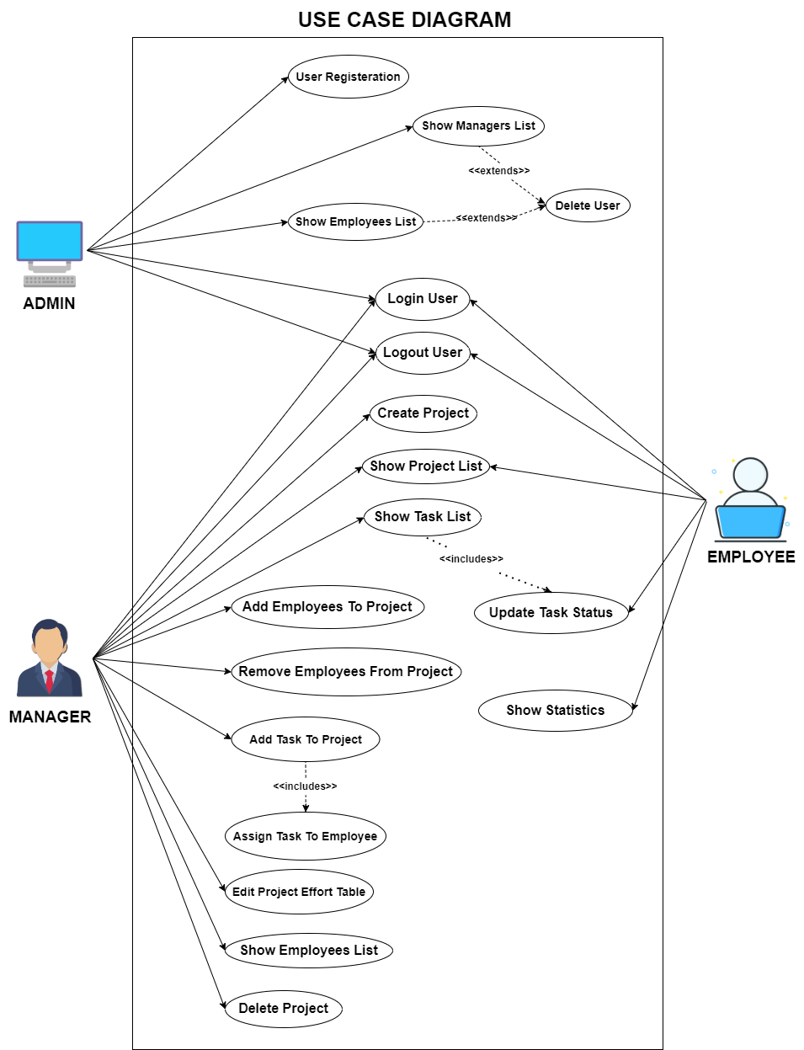

Figure 4‑1Use Case Diagram

## CLASS DIAGRAM

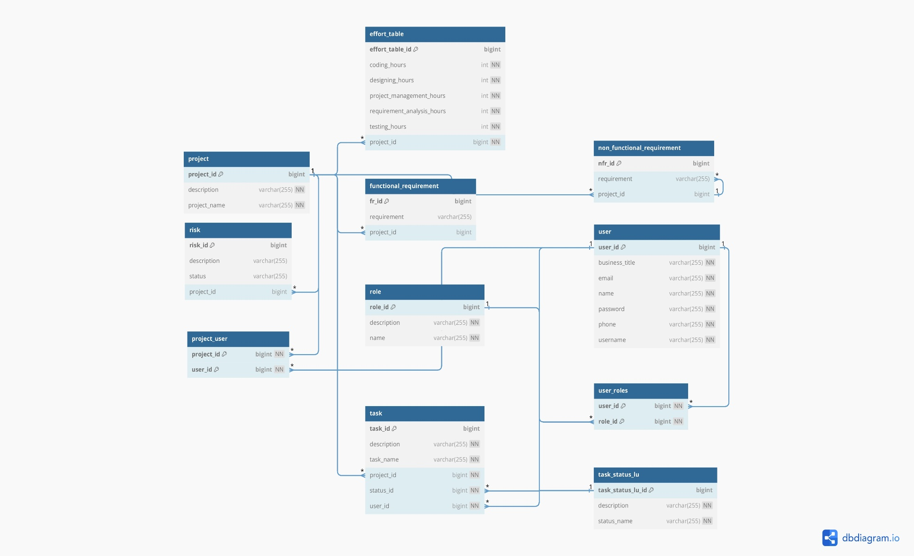

Figure 4‑2 Class Diagram

# SOFTWARE DEVELOPMENT LIFE CYCLE

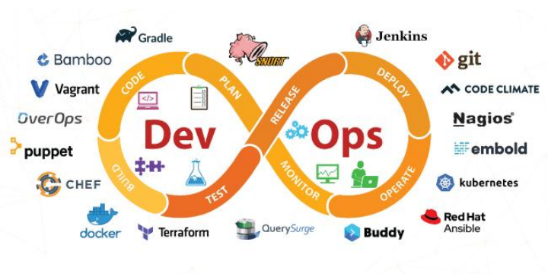

Figure 5‑1 DevOps Tool Chain

In the development lifecycle of WorkWize, DevOps practices are seamlessly integrated to automate and enhance efficiency across various stages. WorkWize leverages Git and GitHub for code management, enabling collaborative version control and efficient code management. Maven orchestrates the build process, while JUnit facilitates automated testing, ensuring high code quality and functionality. For delivery, WorkWize utilizes DockerHub as the central repository for storing and managing Docker images, simplifying the delivery process. Ansible automates deployment, ensuring consistency and reliability, with WorkWize deployed within Docker containers on Ubuntu servers. Additionally, the ELK Stack, comprising Elasticsearch, Logstash, and Kibana, is utilized for monitoring and visualizing logs, enabling effective monitoring and troubleshooting. Through this integrated approach, WorkWize benefits from increased efficiency, faster deployment cycles, and improved collaboration among development and operations teams.

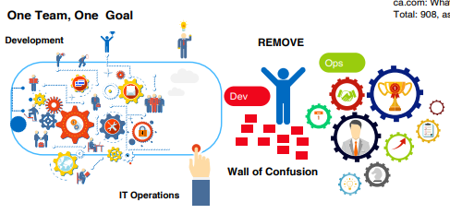

Figure 5‑2 DevOps Benefits

## FRONTEND

Angular is a TypeScript-based free and open-source web application framework, maintained by Google. Its primary purpose is to develop single-page applications (SPAs). As a framework, Angular offers several clear advantages, including robustness, scalability, and maintainability. It provides a standard structure for developers to work with, facilitating efficient development and collaboration. One of Angular's key features is its component-based architecture, which promotes modularity and code reusability. Additionally, Angular comes with a comprehensive ecosystem of tools and libraries, such as Angular Material for UI components and RxJS for reactive programming. These features enable users to create large applications in a maintainable manner, with built-in support for features like routing, forms, HTTP client, and state management. Overall, Angular empowers developers to build modern, feature-rich web applications with ease and efficiency.

### **INSTALLATION**

1. Update the System:

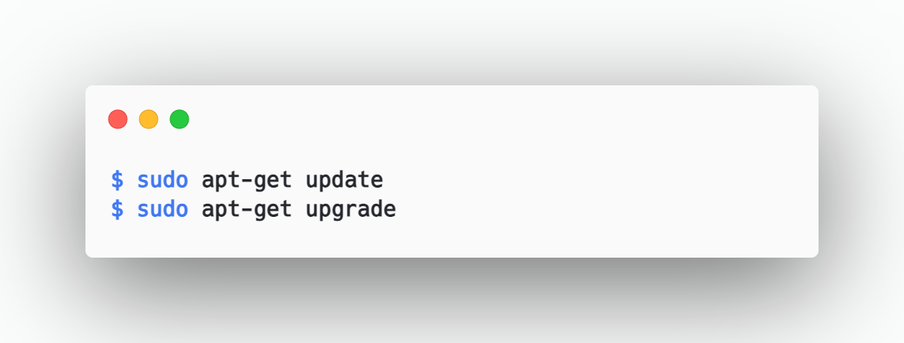

Figure 5‑3 Update System

1. Prerequisite installations:

Before starting with Angular, make sure that Node.js is already installed in the system.

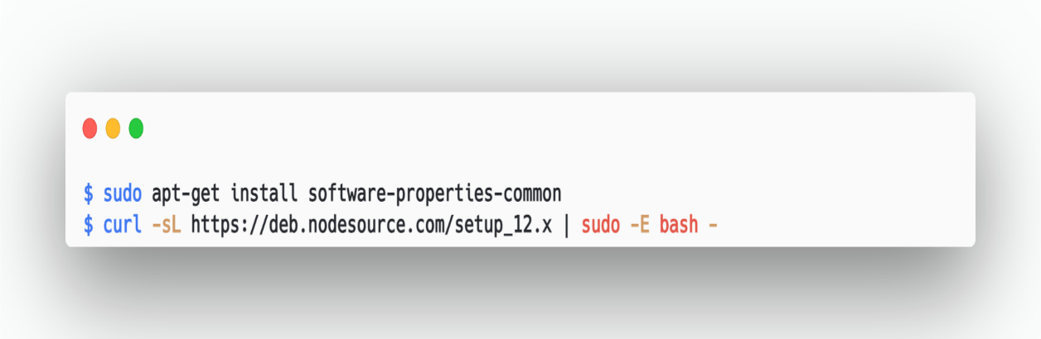

Figure 5‑4 Prerequisite Installation

1. Install Angular CLI

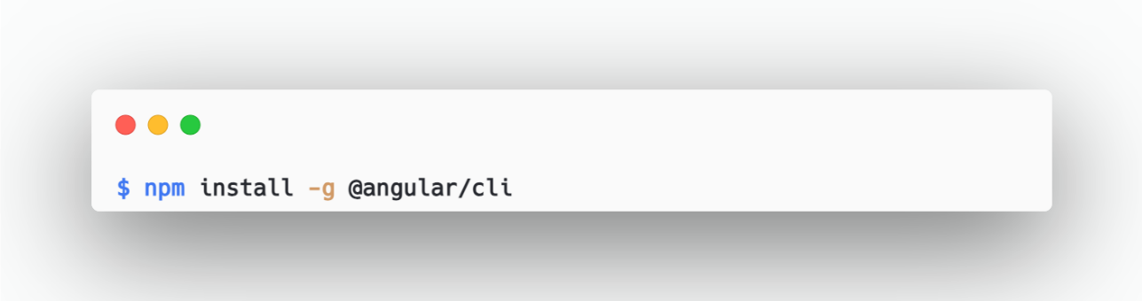

Figure 5‑5 Angular Installation

1. Verify angular installations

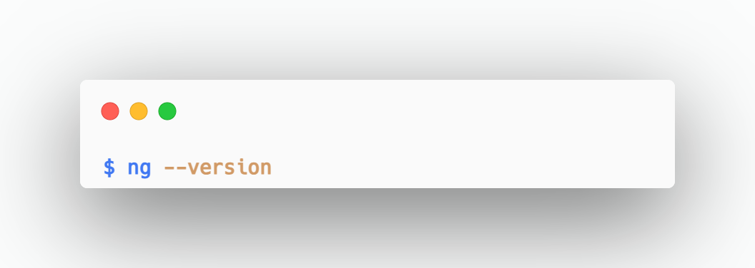

Figure 5‑6 Angular Installation Verification

1. Running the application on localhost

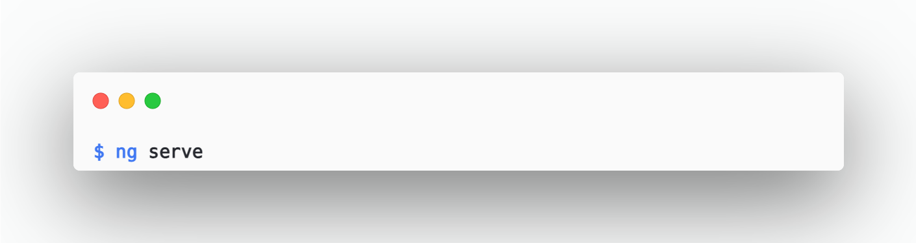

Figure 5‑7 Run Angular

### **SOURCE CODE MANAGEMENT**

Source code management is the practice of tracking modifications to source code.Using SCM, we can maintain the current state of the software using which developers can work on newer versions for features. Multiple developers from the same team can work on a single project collaborating among them and then resolving the conflicts in the code when they push them to the repository. For Software configuration management we shall be using Github.

We have created a similar one for the WorkWize Application and can be found at

**FRONTEND:**

The SCM handles our code and is used to connect as input to Jenkins.

Once the developer creates the project and adds any features these can be pushed to the Github by following the below steps:

* Initiate the current git repository

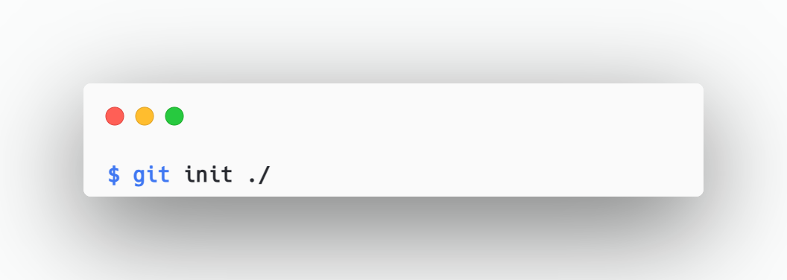

Figure 5‑8 Git Initialization

* Add Remote Origin

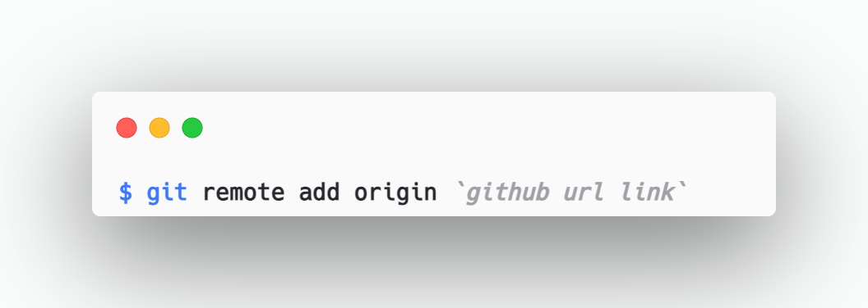

Figure 5‑9 Add Remote Origin

* Add Files to stage. If we put ‘.’ then all files will be added to the stage.

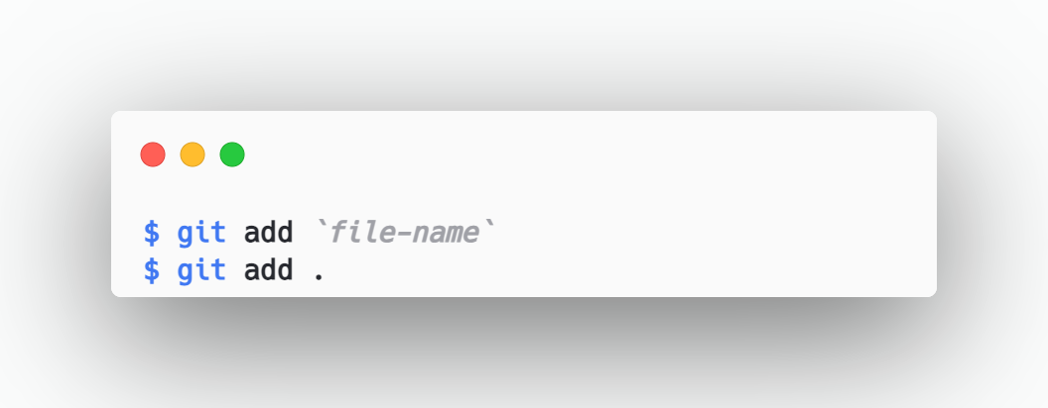

Figure 5‑10 Staging File

* Commit Changes to the Local Repository. All the staged files will be committed.

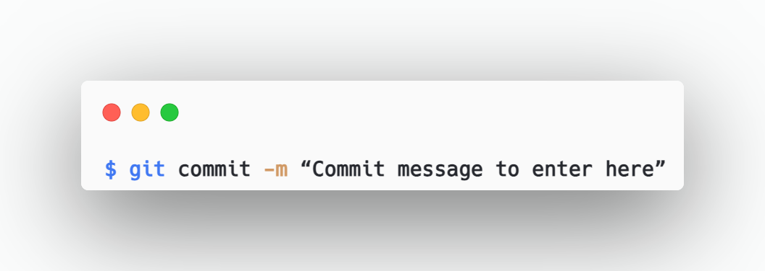

Figure 5‑11 Git Commit

* Push Changes to Remote Repository.

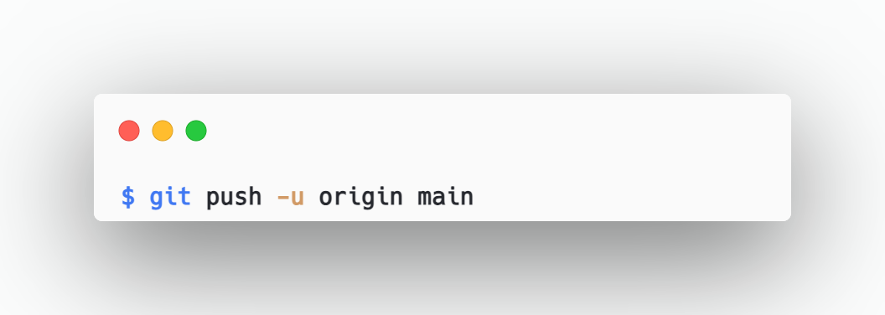

Figure 5‑12 Git Push

* For Cloning the Project:

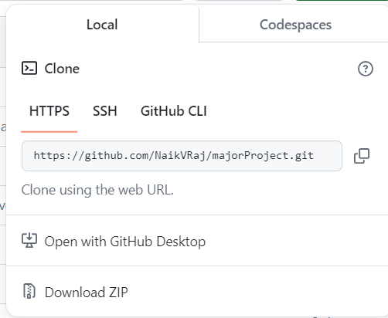

Figure 5‑13 Front End Git Clone - I

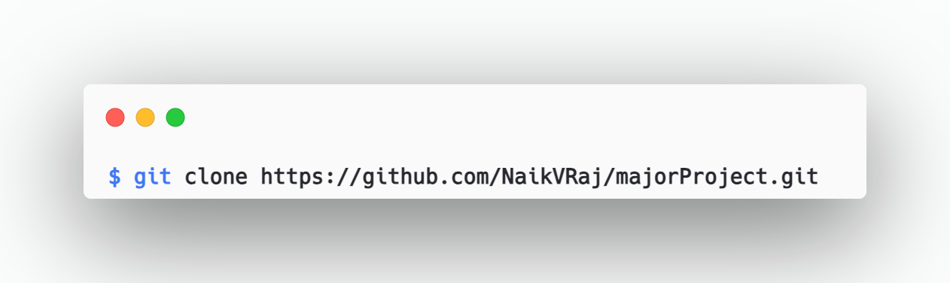

Figure 5‑14 Front End Git Clone - II

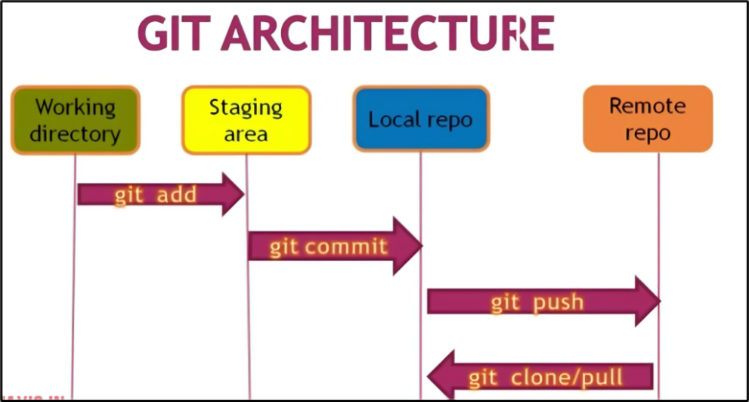

Figure 5‑15 Git Architecture

### **CONTINUOUS INTEGRATION**

Continuous Integration (CI) is a development practice where developers integrate code into a shared repository frequently, preferably several times a day. Each integration can then be verified by an automated build and automated tests. While automated testing is not strictly part of CI it is typically implied. Few Popular tools for CI are Jenkins, Travis CI, GitLab CI, Github actions, and many more.



Figure 5‑16 Continuous Integration

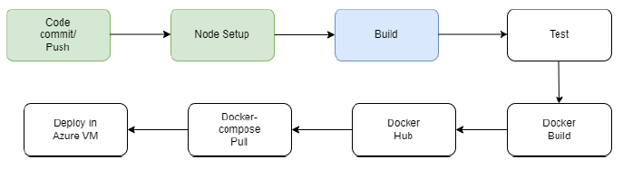

Figure 5‑17 Second Step

After the developer commits & pushes the code, the jenkins workflow will be triggered

and the build will start.

This command builds and serves the application. It rebuilds the application if changes

occur. Here project is the name of the application as defined in angular.json.

This command compiles an angular application/library into an output directory named

dist at the given path.

**Options used & Syntax:**

– configuration=production: A named build target, as specified in the "configurations"

section of angular.json.

Each named target is accompanied by a configuration of option defaults for that target. Setting this explicitly overrides the "--prod" flag.d

Here, we are using productions we want to get production environment settings while

building an angular application/binary.



Figure 5‑18 Production Environment

### **DOCKER BUILD AND PUSH**

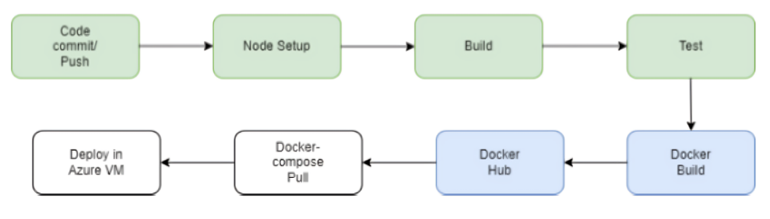

Figure 5‑19 Third Step

Docker is a software platform that allows you to build, test, and deploy applications quickly. Docker packages software into standardized units called containers that include everything the software needs to run: libraries, system tools, code, and runtime. Containers ensure that your application runs consistently in any environment, from development to production. Using Docker, you can streamline your development workflow by automating the deployment and scaling of applications.

Using Docker, you can quickly deploy and scale applications into any environment, ensuring your code will run reliably. This is achieved through the flexibility of building and pushing images to Docker Hub. Docker Hub is a cloud-based repository where you can store and distribute Docker images.

The process of creating Docker images involves writing a Dockerfile. A Dockerfile is a simple text file that consists of a set of instructions to build Docker images. These instructions might include specifying a base image, copying application files, installing dependencies, setting environment variables, and defining the command to run the application.

### **DOCKER COMPOSE**

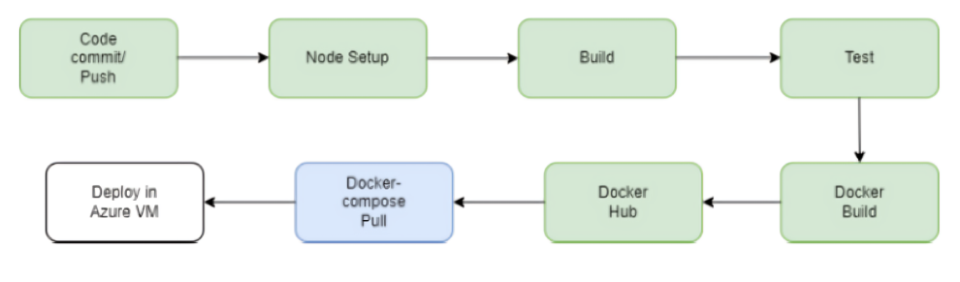

Figure 5‑20 Fourth Step

Docker Compose is a tool that was developed to help define and share multi-container

applications. With Compose, we can create a YAML file to define the services and with a single command, can spin everything up or tear it all down. The big advantage of using Compose is you can define your application stack in a file, keep it at the root of your project repo (its now version controlled), and easily enable someone else to contribute to your project. Someone would only need to clone your repo and start the compose app. We have created a docker-compose.yml file by which we pull the Docker hub frontend container and connect it with the backend & database.

### **FRONT END CODE**

* **DIRECTORY STRUCTURE:**
* All the building components are stored in /components directory
* All the Services which are responsible for API Calls are stored in /services directory
* All the Routings are configured in app-routing.module.ts file
* All the modules are in app.modules.ts
* Testing is enabled done in *spec.ts files in each component.
* All the assets are stored in /assets folder - Router Outlet is configured in
* app.component.html
* **EXPLORING COMPONENTS:**
* For creating new Component

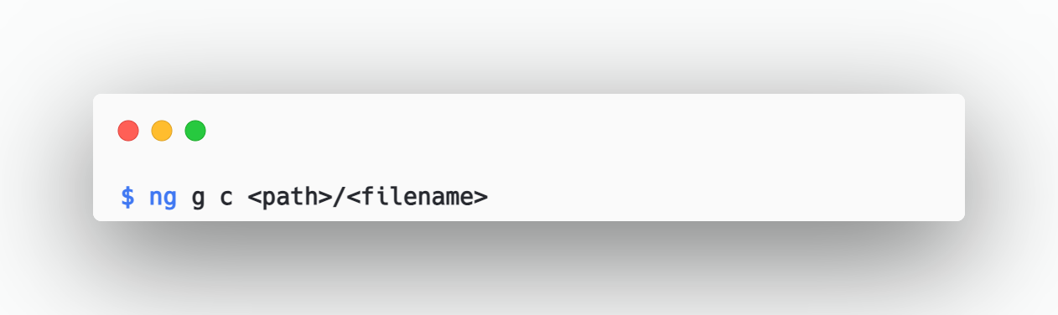

Figure 5‑21 Angular Creating Component

* Following files are created on generating new component:

1. *.html -> Component HTML File
2. *.scss -> Component Styling File
3. *.spec.ts -> Component testing and spec file
4. *.ts -> Component Typescript file

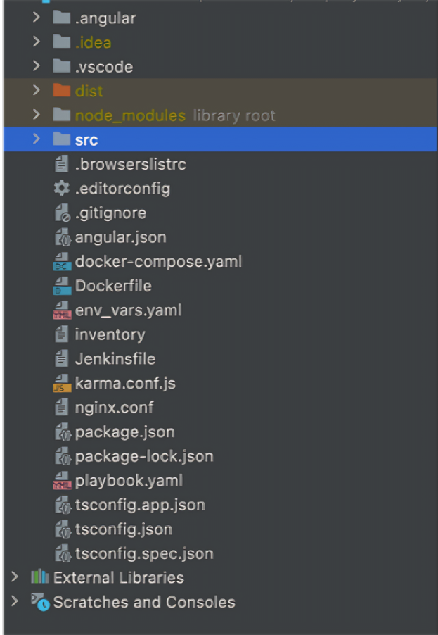

Figure 5‑22 Front End Directory Structure

* **EXPLORING SERVICE FILE:**
* For creating a service:

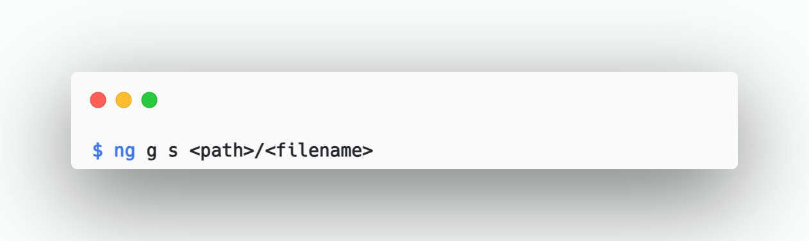

Figure 5‑23 Angular Creating Service

* Here “g” stands for generate and “s” stands for service
* Following files are created:

1. *.service.ts -> Typescript file for writing services
2. *.service.spec.ts

* **API CALLS:**
* **Making the API Calls to the Backend:**

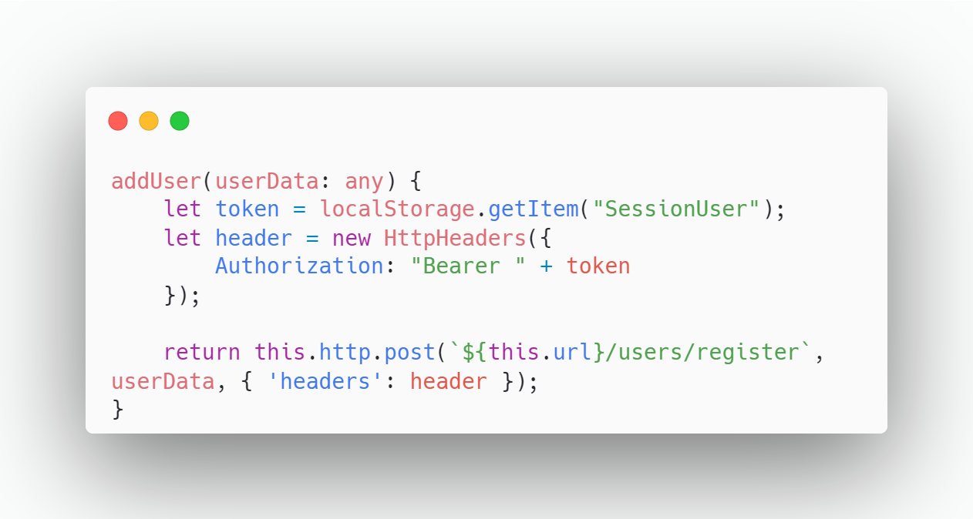

Figure 5‑24 API Call to Back End

* **Calling the API from service file to Component:**

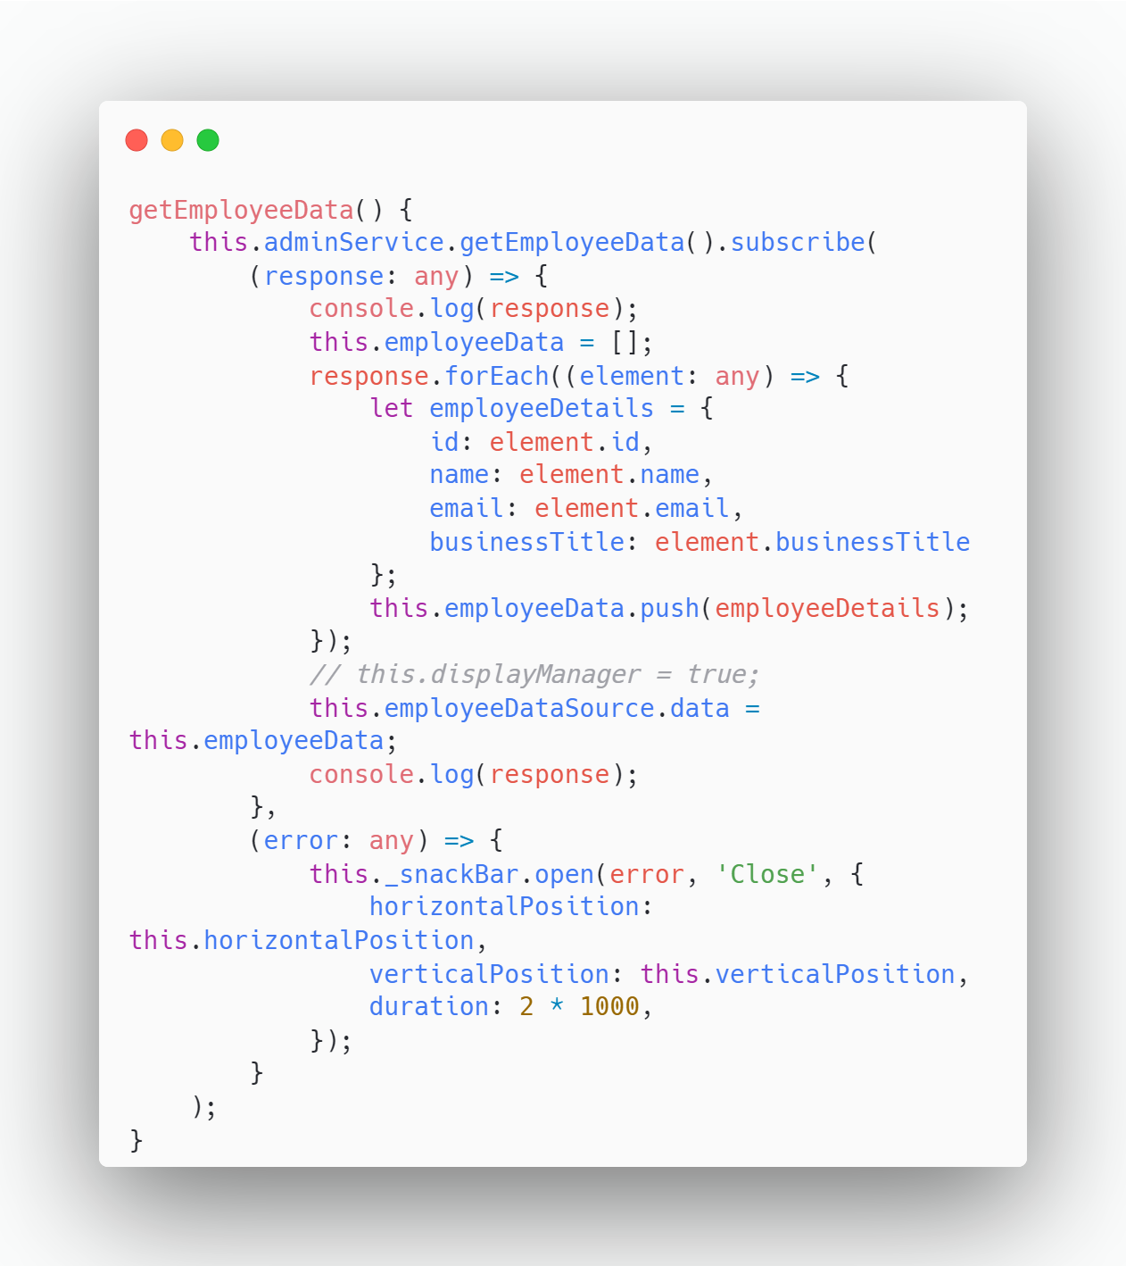

Figure 5‑25 API Call from Service to Component

## BACKEND

### **INSTALLATION**

1. Install Maven:
   * Maven is a build automation tool used primarily for Java projects, including Spring Boot applications.

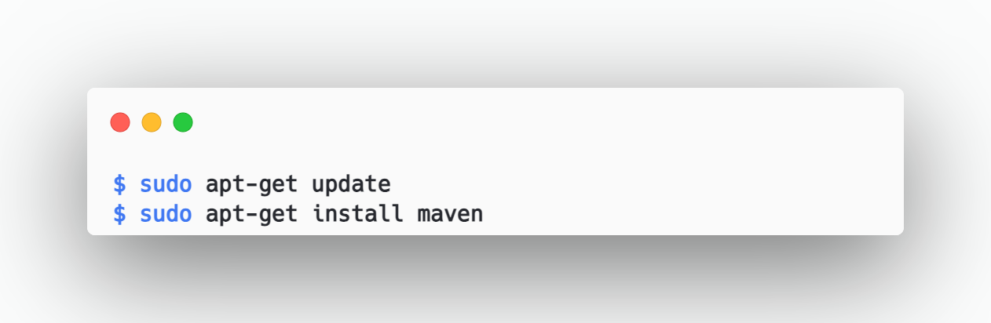

Figure 5‑26 Maven Install

* + Verify the installation

Check the installed version of Maven to ensure its installed correctly.

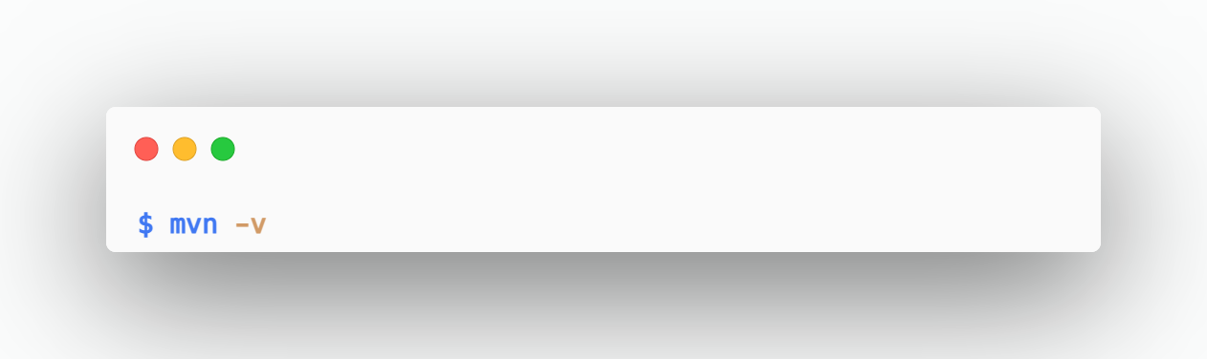

Figure 5‑27 Maven Installation verification

1. Running the Spring Boot Application Locally:
   * Once Maven is installed, you can use it to run your Spring Boot application locally.

Navigate to your Spring Boot project directory

* + Clean and install the project

Use Maven to clean the project and install all dependencies.

* + Run the Spring Boot application

Run your Spring Boot application using Maven.

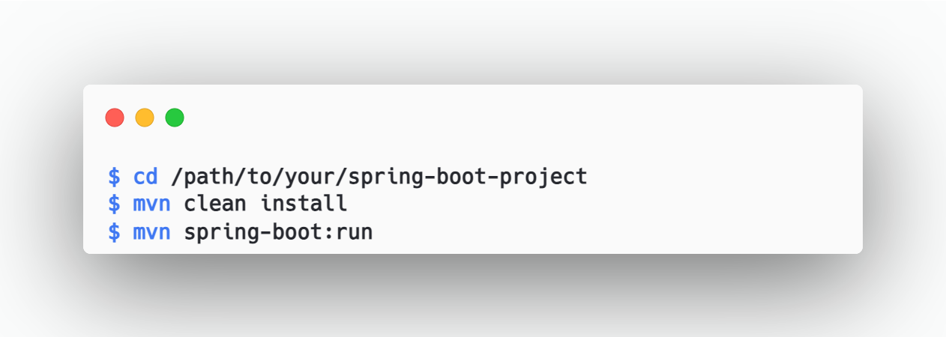

Figure 5‑28 Clean And Install Maven

### **SOURCE CODE MANAGEMENT**

For Source Code Management of BackEnd we used Github. All other basic commands and information already provided in FrontEnd Part.

**BACKEND:** https://github.com/NaikVRaj/majorProject.git

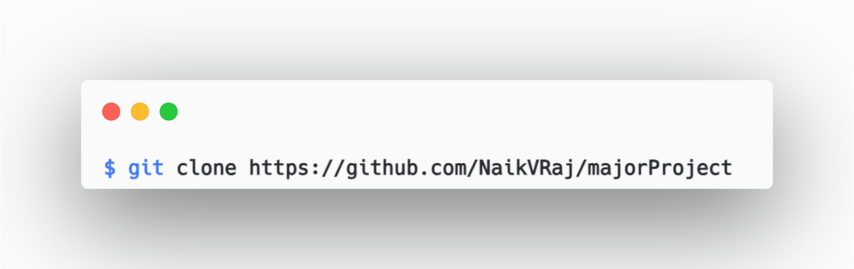

Figure 5‑29 Git Clone

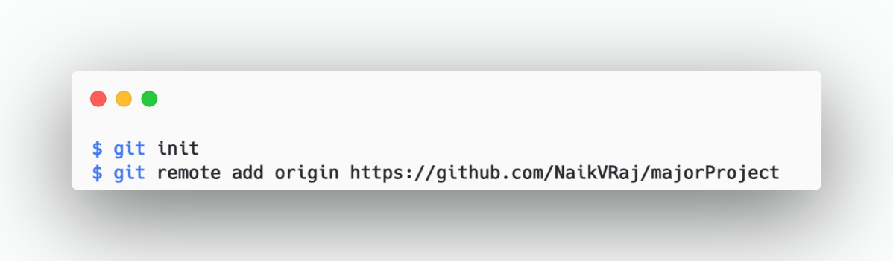

Figure 5‑30 Git initialization Backend



Figure 5‑31 Git Clone Backend - II

### **DOCKER BUILD AND PUSH**

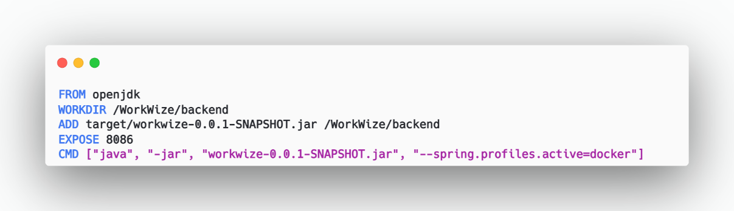

Figure 5‑32 Docker File Backend

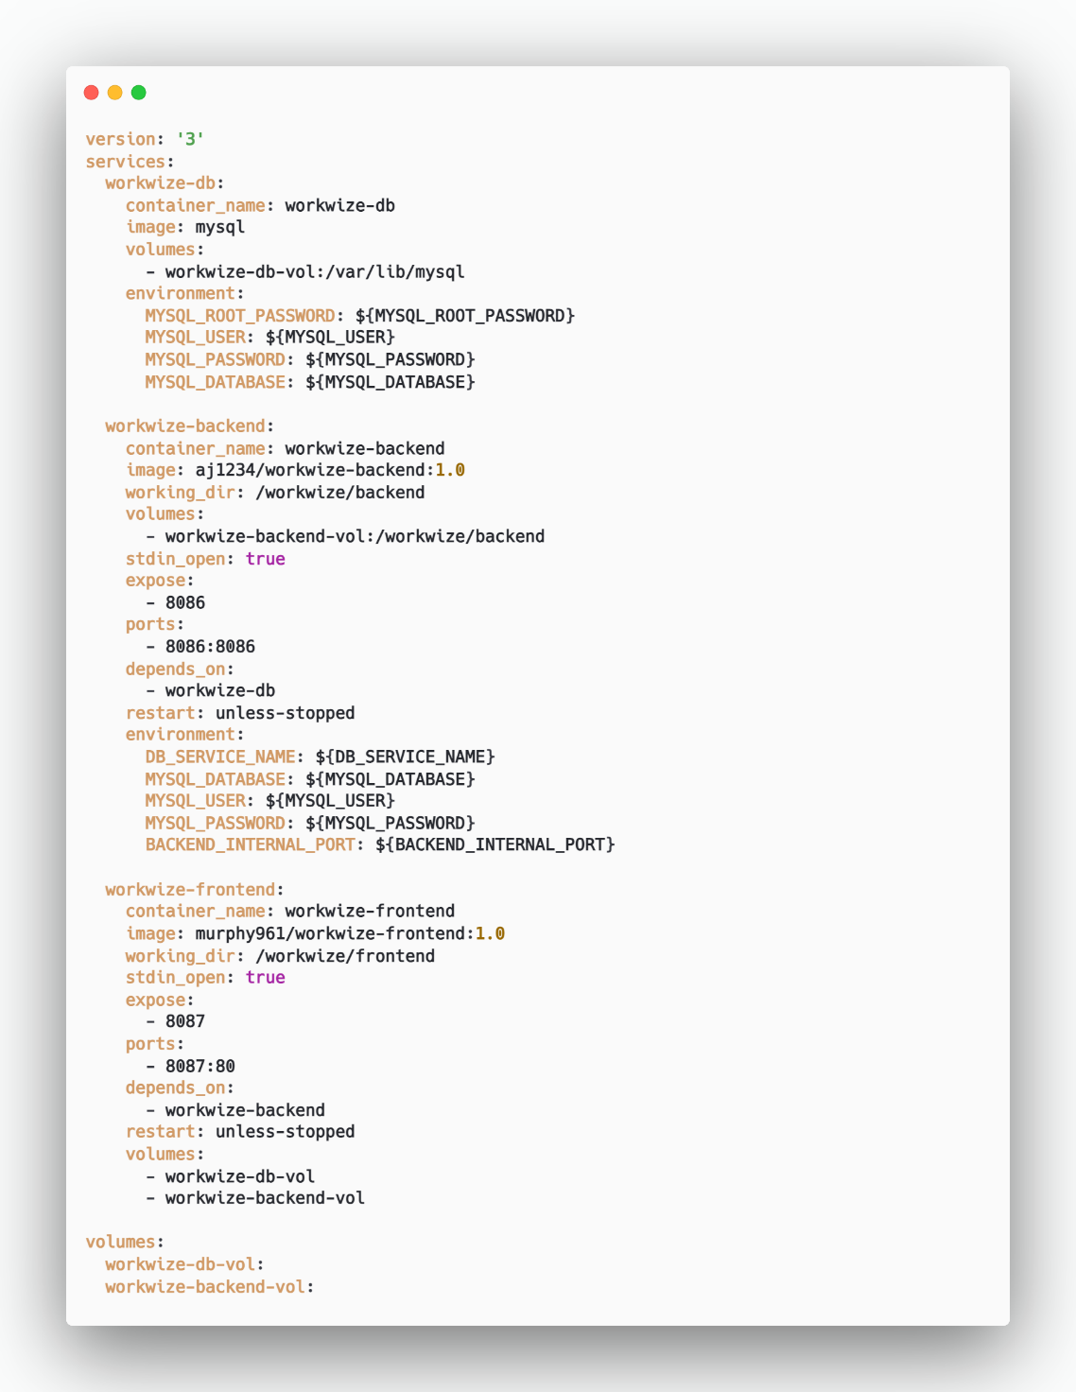

Figure 5‑33 Docker Compose File Backend

1. **Version and Services:**

The Docker Compose file is set to version 3.

It defines three services: WorkWize-db, WorkWize-backend, and WorkWize-frontend.

1. **Containers:**
2. **WorkWize-db:**
   * This container runs the MySQL database.
   * It uses the official MySQL image.
   * Data persistence is ensured by mounting a volume named WorkWize-db-vol to the /var/lib/mysql directory.
   * Environment variables are set for the MySQL root password, user, password, and database name.
3. **WorkWize-backend:**

* This container runs the backend application.
* It uses a custom image (aj/WorkWize-backend:1.0).
* The working directory inside the container is set to /WorkWize/backend.
* A volume named WorkWize-backend-vol is mounted to the /WorkWize/backend directory.
* The container exposes port 8086 for communication.
* It depends on the WorkWize-db container.
* Environment variables are configured for the database service name, database name, user, password, and backend internal port.

1. **WorkWize-frontend:**

* This container runs the frontend application.
* It uses a custom image (aj/WorkWize-frontend:1.0).
* The working directory inside the container is set to /WorkWize/frontend.
* The container exposes port 8087 for communication.
* It depends on the WorkWize-backend container.

1. **Network:**

Both the WorkWize-backend and WorkWize-frontend containers are part of the same network named docker_net.

1. **Data Persistence:**

The MySQL container (WorkWize-db) uses a volume (WorkWize-db-vol) for data persistence.

This ensures that user data is retained even when the server is down.

### **CONTINUOUS DEPLOYMENT USING ANSIBLE**

* Ansible is used for deployment of all services onto the VM via docker-compose.
* Basically, Ansible uses a playbook to do these tasks.
* Below is the playbook that we used for the same.

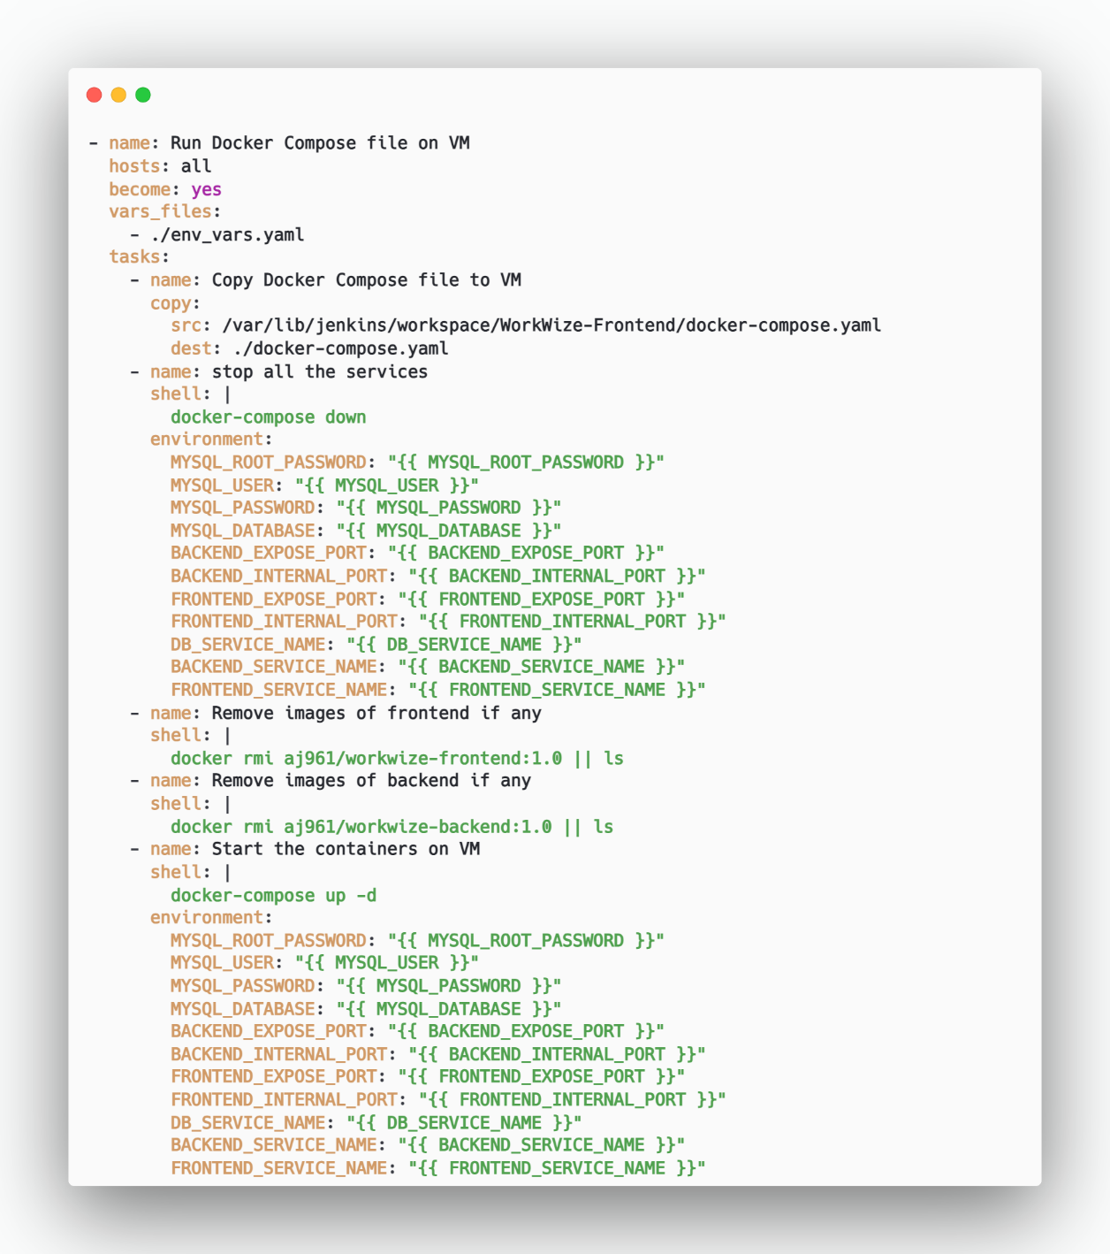

Figure 5‑34 Ansible Playbook Backend

1. **Copy Docker Compose File to VM**

* The playbook starts by copying the docker-compose.yaml file from the Jenkins workspace to the VM.
* The source path is /var/lib/jenkins/workspace/WorkWize-Frontend/docker-compose.yaml.
* The destination path on the VM is ./docker-compose.yaml.

1. **Stop All Services**

* The playbook executes the command docker-compose down to stop all services defined in the Docker Compose file.
* Environment variables are used for configuration, such as MySQL credentials, backend and frontend ports, and service names.

1. **Remove Images of Frontend (if any)**

* The playbook attempts to remove the Docker image aj961/workwize-frontend:1.0.
* If the image does not exist, it lists the available images.

1. **Remove Images of Backend (if any)**

* Similar to the frontend, the playbook tries to remove the Docker image aj961/workwize-backend:1.0.
* If the image is not found, it lists the existing images.

1. **Start Containers on VM**

* Finally, the playbook starts the containers using docker-compose up -d.
* Environment variables are again used for configuration, including MySQL credentials, backend and frontend ports, and service names.

### **BACKEND CODE**

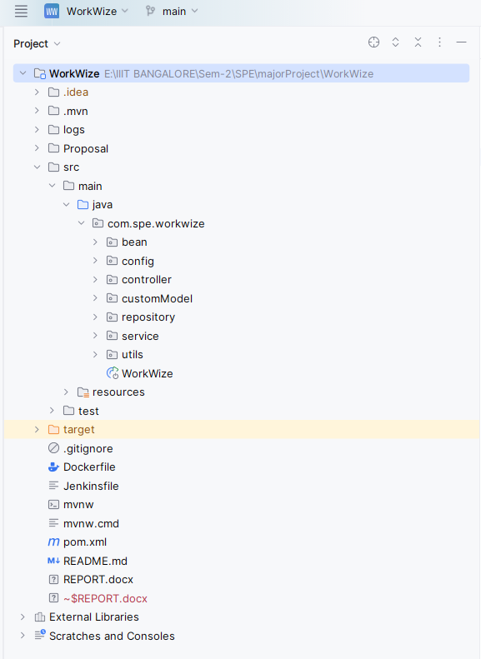

Figure 5‑35 Backend Directory Structure

1. **API Controllers *(/controllers)*:**

* API controllers handle incoming HTTP requests and define the endpoints for your application.
* Each controller class corresponds to a specific resource or functionality (e.g., user, product, order).
* Controllers are responsible for validating input, invoking service methods, and returning appropriate responses.
* Example: If you have an endpoint for creating a new user, you’d define a UserController with methods for handling POST requests related to user creation.

1. **Business Logic *(/service)*:**

* The service layer contains the core business logic of your application.
* Services encapsulate complex operations, data processing, and interactions with other components.
* They often interact with repositories (explained next) to retrieve or update data.
* Example: A UserService might have methods for user authentication, profile updates, and password resets.

1. **DB Schemas *(/bean)*:**

* The /bean directory likely contains data models or entity classes.
* These classes represent the structure of your database tables.
* Annotations (such as @Entity, @Table, and @Column) define the mapping between Java objects and database tables.
* Example: If you have a user entity, it would define properties like id, username, and email.

1. **JPA Repositories *(/repository*):**

* JPA (Java Persistence API) repositories provide an abstraction layer for database operations.
* They allow you to perform CRUD (Create, Read, Update, Delete) operations on entities.
* Repositories extend interfaces like JpaRepository and provide methods for querying data.
* Example: A UserRepository might have methods like findByUsername or findAllByRole.

1. **JWT Configuration *(/config*):**

* The /config directory holds configuration details related to JWT (JSON Web Token) authentication.
* JWTs are commonly used for securing APIs and managing user sessions.
* Configuration includes settings like token expiration time, secret keys, and token validation rules.
* Example: You’d configure how to generate and validate JWTs for user authentication.

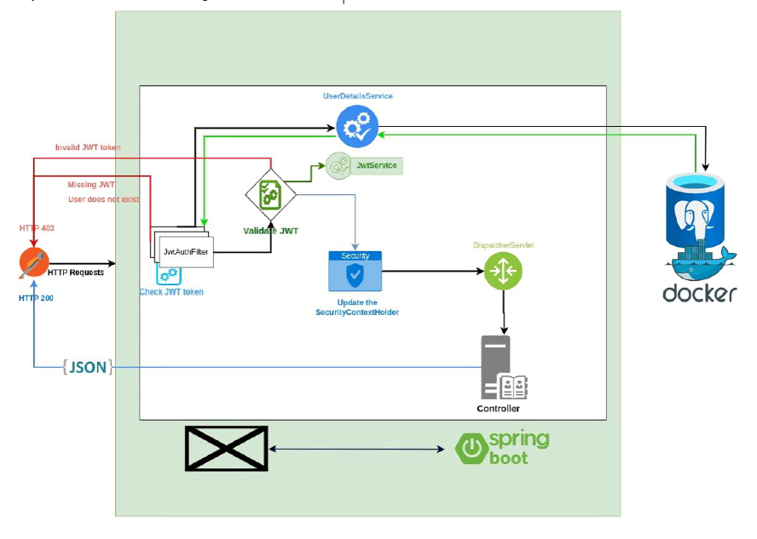

Figure 5‑36 JWT Token Verification

1. **Generating JWTs (Server-side)**

* **User Authentication:**

When a user logs in or provides valid credentials, authenticate them against your user database.

* **Generate a JWT:**

Use a JWT library (e.g., jsonwebtoken in Node.js) to create a JWT.

Include relevant claims (payload) such as user ID, roles, and expiration time.

Sign the token using a secret key known only to your server.

* **Send the JWT to the Client:**

Return the JWT to the client (usually in the response body or a custom header).

The client will store this token for subsequent requests.

1. **Using JWTs in Requests (Client-side)**

* **Include the JWT in Requests:**

For each API request, include the JWT in the Authorization header:

Authorization: Bearer YOUR_JWT_TOKEN

1. **Validating JWTs (Server-side)**

* **Extract the Token:**

In your server, extract the JWT from the Authorization header. Verify that the token is well formed (contains 3 parts: header, payload signature).

* **Verify the Signature:**

Use the same secret key used during token generation to verify the token’s signature.

If the signature is valid, proceed; otherwise, reject the request.

* **Check Expiration:**

Ensure the token hasn’t expired (check the exp claim).

Reject expired tokens.

* **Additional Validation (Optional):**

Validate other claims (e.g., issuer, audience) if needed.

Check user roles or permissions stored in the token.

1. **Handling Unauthorized Requests**

* **Unauthorized Requests:**

If the token is missing, invalid, or expired, return an HTTP 401 (Unauthorized) response.

Prompt the client to re-authenticate or obtain a new token.

1. **Refreshing Tokens (Optional)**

* **Token Refresh:**

To avoid frequent logins, issue a short-lived refresh token alongside the access token.

When the access token expires, use the refresh token to obtain a new access token.

1. **Logging Out (Optional)**

* **Logout:**

To log out a user, invalidate the token on the server side.

Maintain a blacklist of revoked tokens or use a short token expiration time.

1. **Best Practices**

* **Keep Secrets Secure:**

Safeguard the secret key used for signing tokens. Avoid hardcoding it in your code or exposing it publicly.

* **Short Token Lifetimes:**

Set a reasonable expiration time (not too long). Regularly rotate keys and invalidate old tokens.

* **Use HTTPS:**

Always use HTTPS to prevent token interception.

1. **Application Properties *(application.properties)*:**

* This file contains various configuration properties for your Spring Boot application.
* You can set database connection details, logging levels, security settings, and more.
* Example properties: spring.datasource.url, spring.jpa.hibernate.ddl-auto, server. port.

1. **Data Initialization (*data.sql)*:**

* The data.sql file is used for initializing data in your database during application startup.
* You can insert initial records, create default users, or set up reference data.
* Example: If your application requires predefined roles (e.g., admin, user), you’d insert them in this file.

## CONTINUOS MONITORING

The proactive method of observing systems with the goal of preventing downtime and

outages, is monitoring. It involves measuring current behavior against predetermined baselines. Some of the commonly observed devices are CPU usage, storage capacities, request hits i.e network traffic, etc. by which we can find the root cause of the failure.

Elasticsearch is a modern analytics and search engine which is based on Apache Lucene. Using this we can draw meaningful information from index logs created by applications. We can use elastic to manage, store and search data which can come in handy in Logs, Metrics, Application monitoring, Endpoint security, and Search backend.

We can use ELK stack locally or kibana & elasticsearch can be run on the cloud and we can send logs using logstash installed on the host machine. Here, we have used cloud

approaches as for installing ELK stack RAM requirements were high.

Using ELK we will be doing continuous monitoring. ELK uses three open-source projects namely Elastic search, Logstash, Kibana respectively.

* Elasticsearch is a distributed, free and open search and analytics engine for all types of data, including textual, numerical, geospatial, structured, and unstructured. Elasticsearch is the central component of the ELK stack Logstash is a free and open server-side data processing pipeline that ingests data from a multitude of sources, transforms it, and sends it to your favorite “stash”.
* Kibana is a free and open user interface that lets you visualize your elasticsearch data and navigate the elastic stack.

Do anything from tracking query load to understanding the way requests flow through apps.

* For logging we have used log4j2, a library useful for logging.

### **ELASTIC SEARCH**

* First, we need to create an account on Elasticsearch cloud.

1. Go to https://www.elastic.co/ URL and signup.
2. Create the first deployment.
3. Go with the default configuration.
4. Save username & password after the creation of deployment as we will need them hereafter and they will not be shown again.